PERSONAL PROFILE
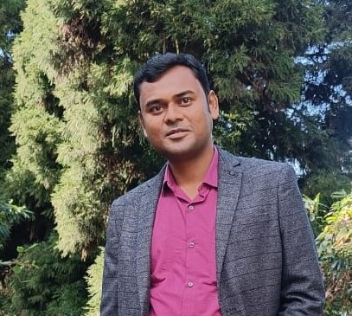

Recent Photograph

Name:- Debesh Mondal

Designation:- Assistant Professor

Date of Birth:- 27.06.1986

Educational Qualification:- Post Graduation

Sl No. | Degree obtain  (Abbreviation of the degree) | College/ university from which the degree was obtained | Year of Passing
1 | Bengali Honours | Scottish Church College | 2007
2 | M.A in bengali | University of Calcutta | 2009

Permanent Address:- Pankajini Apartment, 4th Floor, Bally, 417 G T Road, Howrah-711201

Contact Number:- 8420222866

E-mail:- debesh2009@gmail.com

Date of joining(Service):- 23.11.2015

Specialization:- Comparative Literature

Area of Interest:- Folk songs, Local Culture, Sufi songs, Local Literature.

Faculty Development Programme:-
Sl No. | Year | Name of Programme Participated (OP/ RC/FDP/Summer School/FEP/Others) | Organized By
1. | 2017 | UGC Sponsored 86th Orientation Programme | UGC-HRDC, RANCHI UNIVERSITY
2. | 2022 | Refresher Course on Post-colonial Thought and Indian Literature | UGC-HRDC, UNIVERSITY OF NORTH BENGAL

Research Journal Publication (National and International) :-

National/Regional/ State Level:-
Sl No. | Year of Publication | TITLE | Journal Name | ISSN/ ISBN | Published By
1. | 2011 | Amar Naam Bharat Borsho | Ekaler Bangla Kobita, Anubhaber nijwaswa Bhasye |  | Vidya
2. | 2012 | Myth Jibone, Myth Angike | Samoy Tomake | 2231-5802 | Somnath Das
3. | 2017 | Panyp Somajer Anyo Akhyan: Raktajoba Rahsya | Chhapakhanar Goli | 2347-1808 | Debasish saha

Books and Monographs :-
Sl  No. | Year  Of Publication | Title | Publisher & ISBN No.
1 | 2014 | Itibrittya:Ariyadaha Dakhineswar Abong Ananya (Edited By Debesh Mondal and Nilratan sarkar1 | Offbeat Publishing,  978-81-924769-7-1

Paper Presentation: Conferences/Seminars /Symposia /Workshops:-
Sl no. | Year | Title | Organized by | International  /National  / State Level
1. | 2019 | Gyaner Panyayan:Samprotik Bangla Uponyas | Dept. of Philosophy with IQAC, Vivekananda College, Alipurduar | International
2. | 2019 | Doinandin Jibon Chorja o Odwoito Vedanta Kendrik Vivekanander Vasya | Dept. of Philosophy, Mahishadal Girls College | National
3. | 2023 | Buddhadeb basur ‘Taposwi o Tarangini’: Adhunik Manan o Dwande | Egra Sarada sashi Bhusan college | International
4. | 2023 | Sompadok Rabindranath: Bangla Samoyik Potra | Centre For Studies and Research on Tagore Rabindra Bharati University, Kolkata | International

